1. Firstly, I displayed the data via Power Pivot and Power Query using excel.
2. Then I determined the “**missing** “or “**null**” values in this data.
3. After that, I eliminated this data if there are the same values and they meet.
4. In addition, there were negative values at some points, I converted these values to positive and saved them.
5. After saving, I opened the Power BI program and reviewed my data again, deleted the repeated data (id_numbers, sutün1 etc.) and unnecessary data. Thus, I ensured the data integrity and saved it.
6. At the modeling stage, I chose the common tables as a priority and decided to model them.
7. One of the most important aspects at the modeling stage is to provide convenience to the user, so the model I will create should be easy and understandable.
8. I have modeled my data in the following way where it displays illiterate people in 4 districts.
9. In addition to this model, you can see total population in districts.

**FOR DATA CONVERSION AND DATA PREPARATION-POWER QUERY**

metin, bilgisayar, dizüstü, masa içeren bir resim

Açıklama otomatik olarak oluşturuldu

**DATA VISUALIZATION – POWER BI**

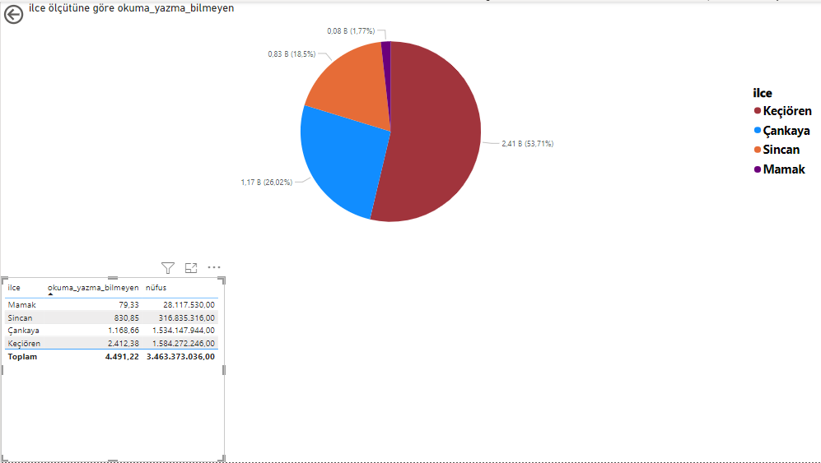

**BY SELECTING THE DISTRICT YOU WANT TO SHOW, YOU WILL SEE ILLITERATES THERE.**

